1.

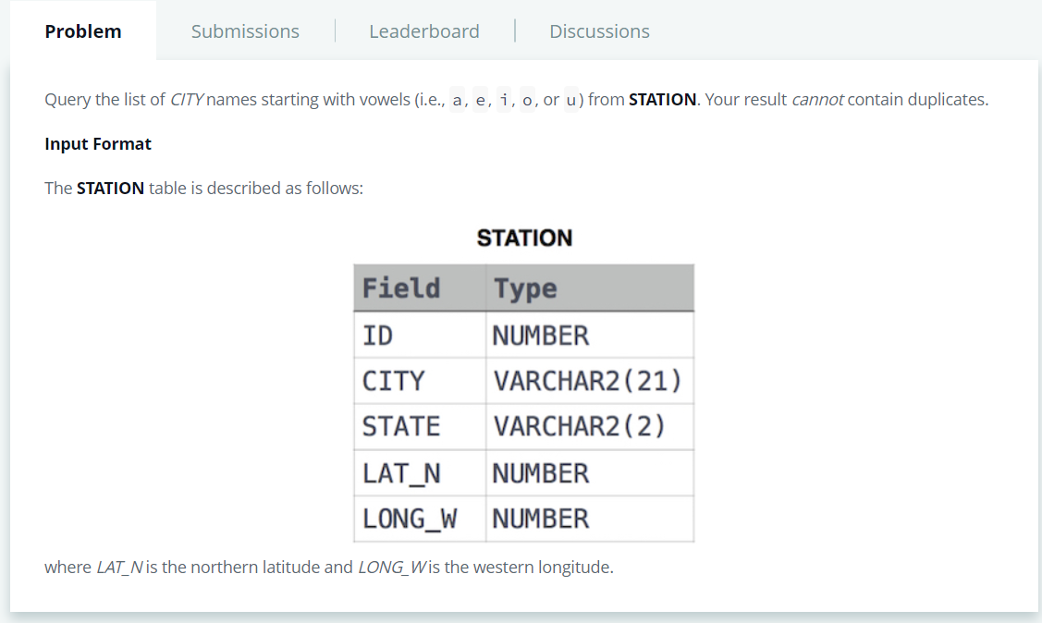

SELECT DISTINCT CITY FROM STATION WHERE CITY LIKE '[aeiou]%';

2.